***ASSIGNMENT 2:***

***COVID-19 UK GOVERNMENT PROJECT***

***JULY 2022***



**Javier Conde Pascual**

**LSE Data Analytics Career Accelerator**

**London School of Economics and Political Science**

*I, Javier Conde Pascual, certify that this is an original piece of work. I have acknowledged all sources and citations. No section of this assignment has been plagiarized.*



**TABLE OF CONTENTS**

Chapter 1. Scenario and system set up 1

Chapter 2. Analysis approach2

* 1. First approach and insights to provided data3
  2. Vaccination - areas to target marketing campaign and first approach to visualisationsx
  3. Visualisations exploration x
  4. Twitter data relating to the #coronavirus hashtag

exploration x

* 1. Time-series analysis and data smoothing8

Chapter 3. Insights 15

Chapter 4. Patterns, trends, recommendations18

Reference list22

List of figures23

Word count: 1061

Own words: 1061

Chapter 1

**Scenario and system set up**

The background, scenario and context provided beforehand for this report are available [here](https://fourthrev.instructure.com/courses/395/assignments/1610). The business problem and key questions for the analyst team and the data are also provided, Figure 1.1. below. This helps also formulating the data analytics problem, building a process to follow accordingly.

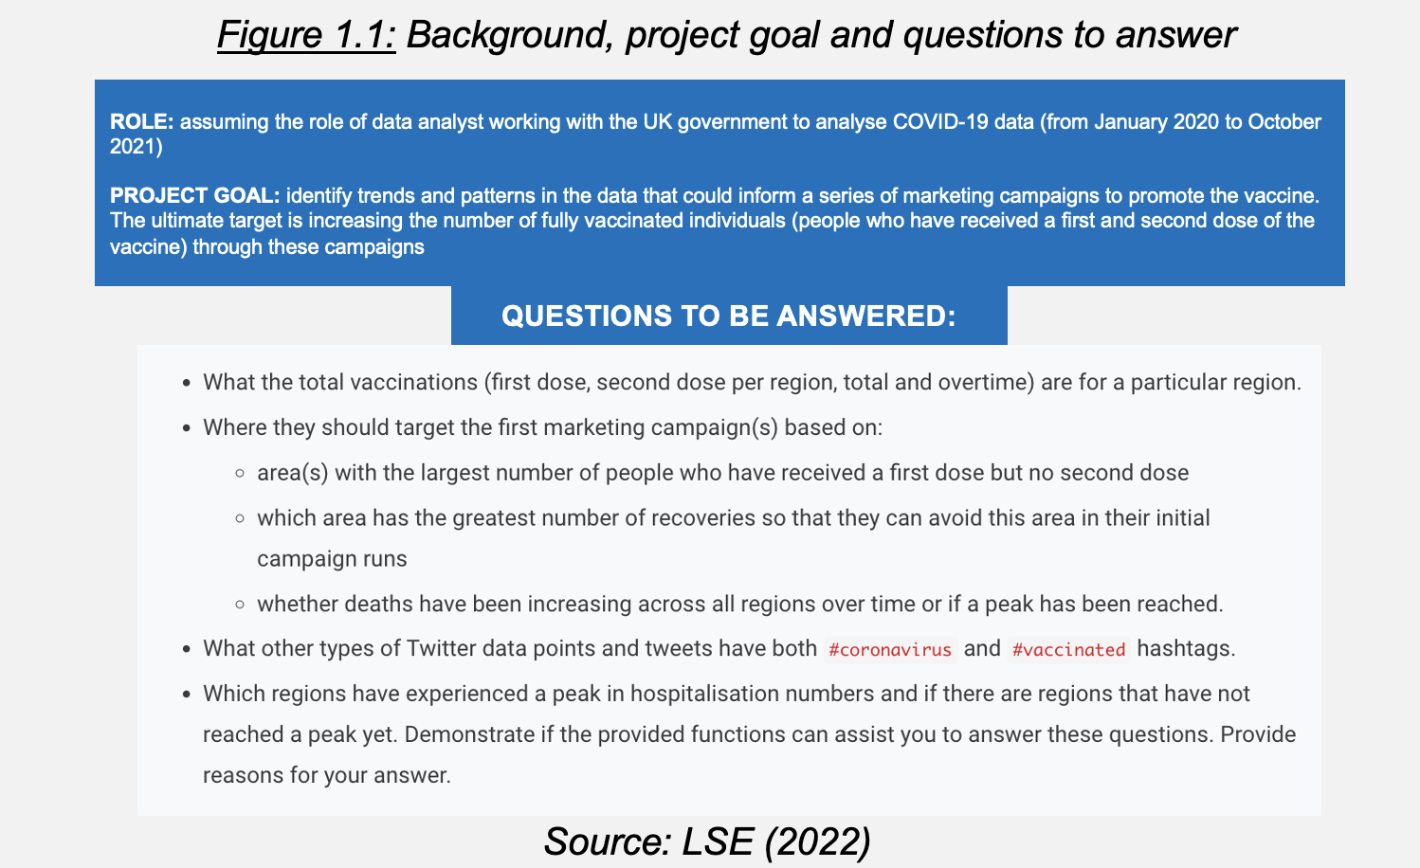

All files generated for this project are stores in GitHub, a distributed centralised control system (CVS). These tools can add solid and measurable value to organisations.Having reliable repositories to accurately control the different versions and updates to the code is essential in the day-to-day work of the team.

Github will help to control overall project progression, different steps we are accomplising along the way and any changes we make to the original Python code block.

Now let’s study the analytical approach used.

Chapter 2

**Analytical approach**

This analytical approach has four key points:

1. Bringing stakeholders and team together, through understanding the importance and risk-reducing advantages of methodical and thorough data analysis and data quality processes.
2. Provide stakeholders with rigorous, accurate and realistic analysis on the data provided through Python and answer all their questions.
3. Assessing the quality of the results obtained, offering useful advice in the case of another epidemic outbreak.
4. All visualizations to be created as accessible as possible through very legible fonts (Arial), big font sizes (10-12 onwards when possible), clear head titles and colors that are color-blind and color-contrast friendly among other features.

File preparation for Github and Phyton (Anaconda/Jupyter environment) is completed (Figures 1.2 and 1.3 below). Let’s now analyze and visualize the data provided with Python.

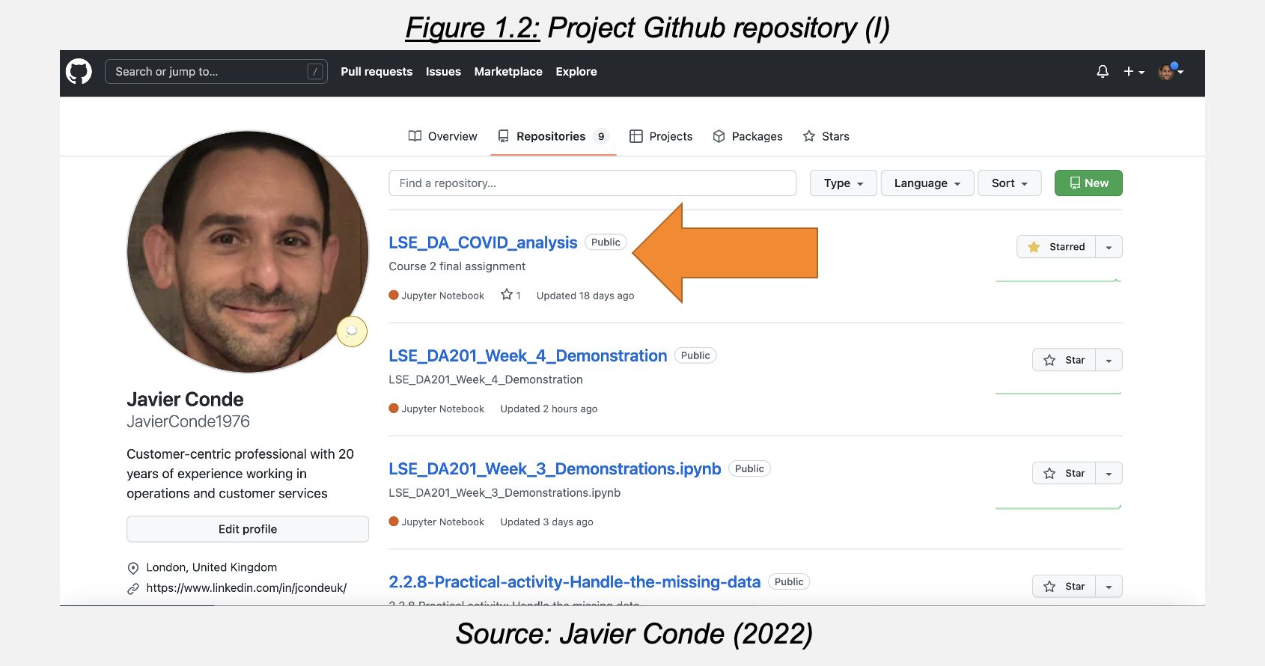

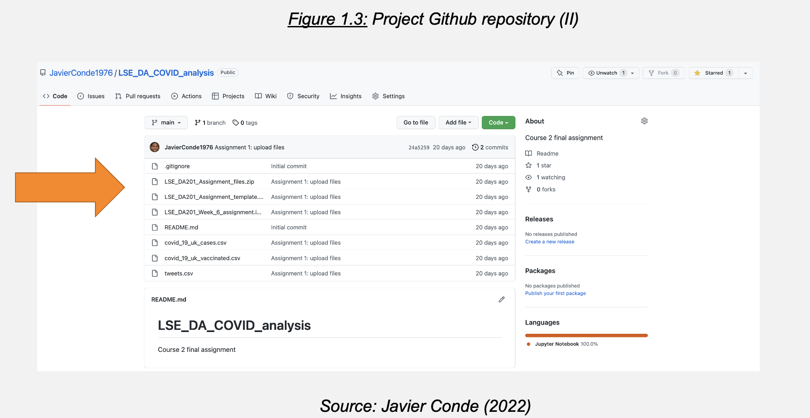

**2.1 First approach and insights to provided data**

Two files provided analyzed for insights:

1. covid_19_uk_cases.csv (COVID cases in the UK in per province)
   * Data cumulative already so no need for extra cumulative calculations
   * 1st case reported in Gibraltar 2020-03-03
   * Data available only until 14 Oct 2021
   * Peak in year 2020: 31 December 2040 reported cases; peak 2021: increase of 280% with 5727 reported cases on 14 October (Figure 2.1)
2. covid_19_uk_vaccinated.csv (vaccination data)
   * First vaccinations on 2021-01-11
   * Data quality questions as possible discrepancies on vaccination info vs real population uncovered: i.e., Gibraltar, 5,606,041 complete vaccination cycle (CVC) on total population of Gibraltar of 33,691 (Figure 2.2) (Source: <https://datatopics.worldbank.org/>). Cumulative deaths in line with real data (Figure 2.3) (Source: DataCommons.org)
   * CVC percentage (95.5%) consistent across all United Kingdom provinces

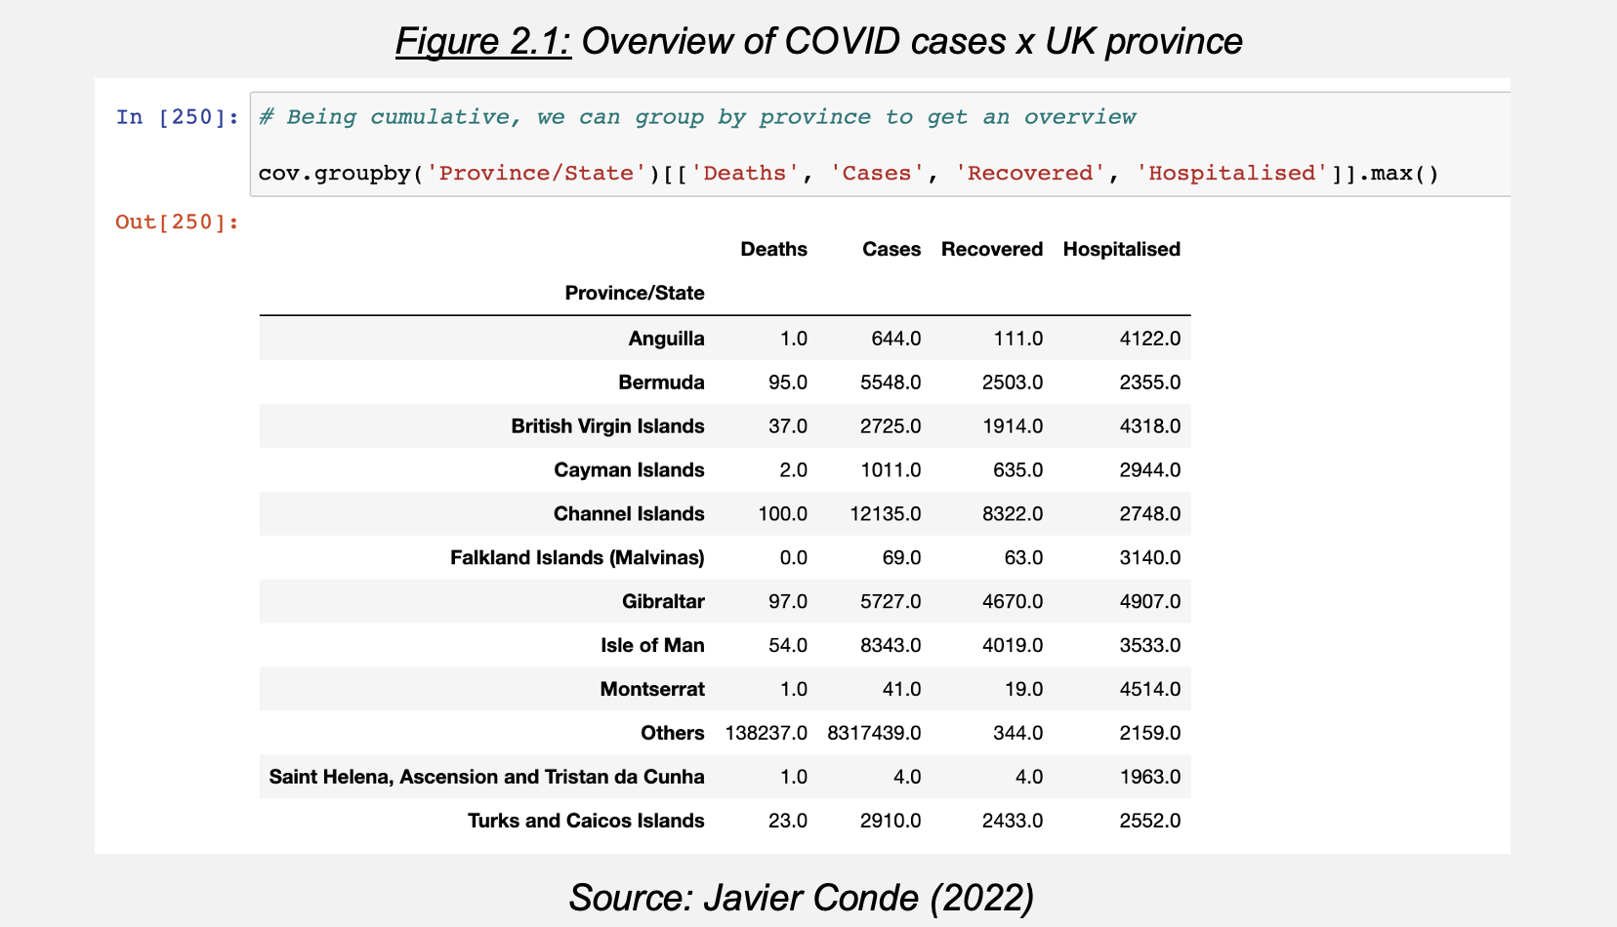

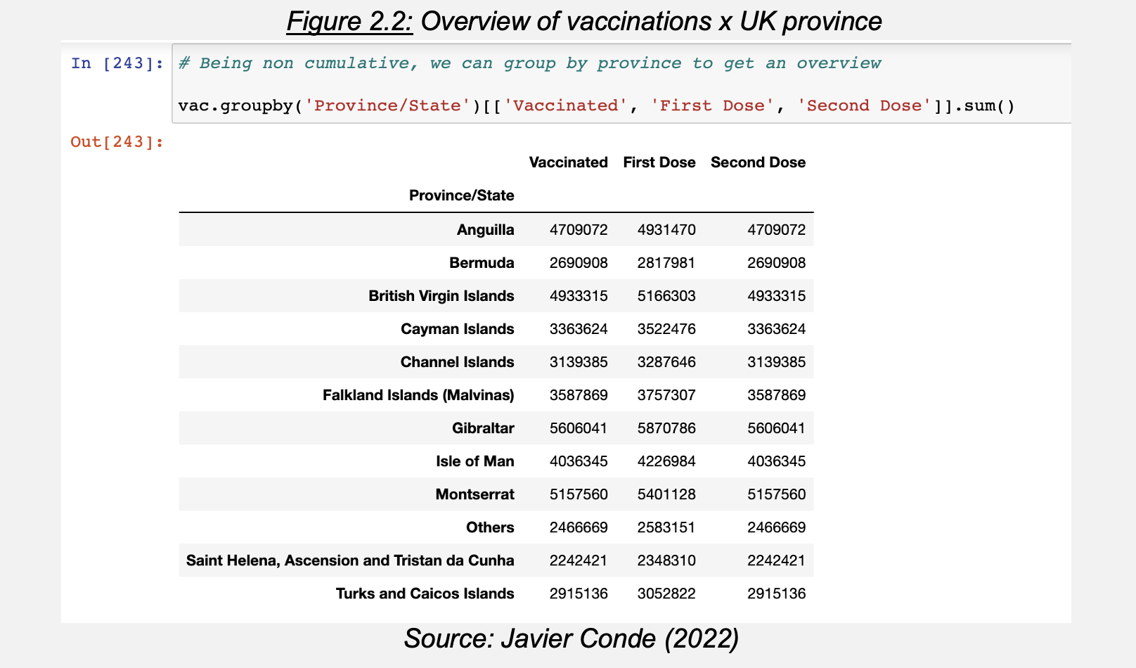

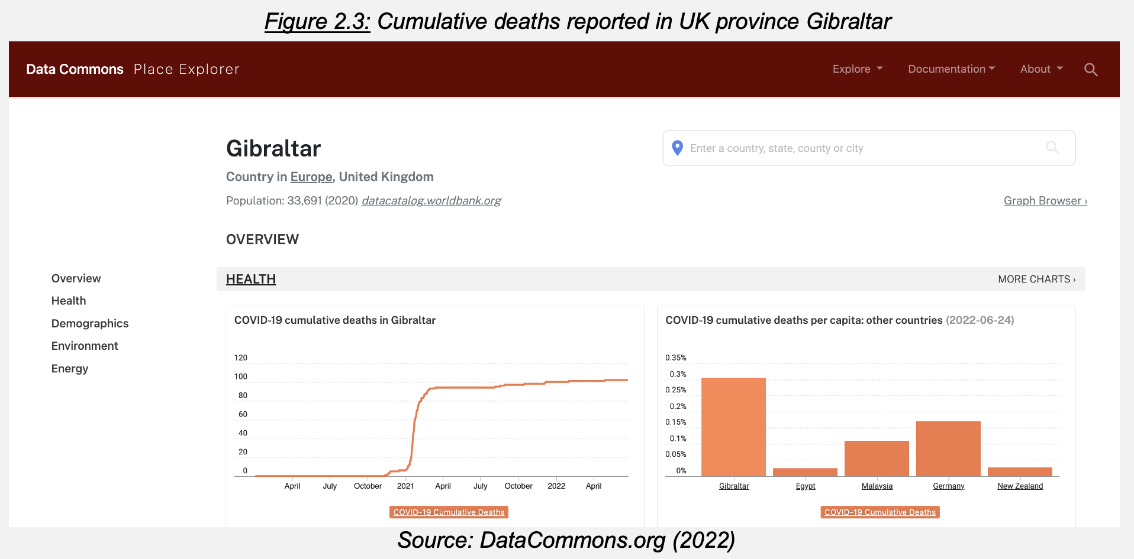

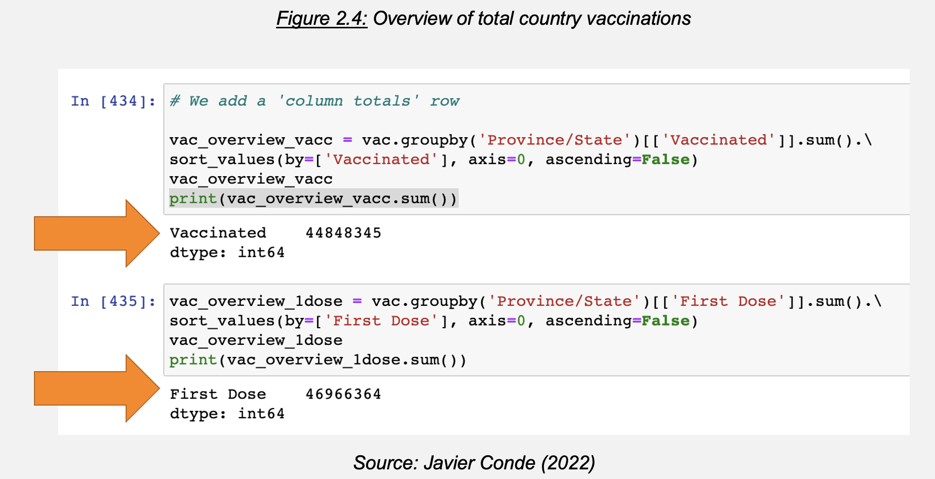

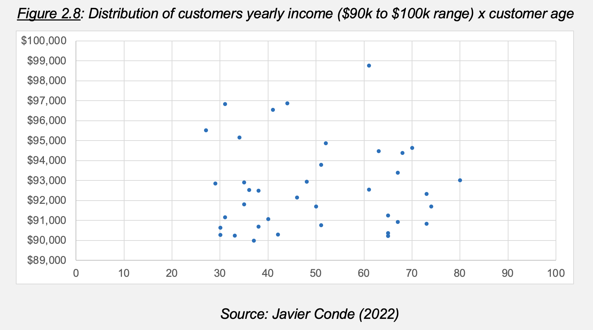

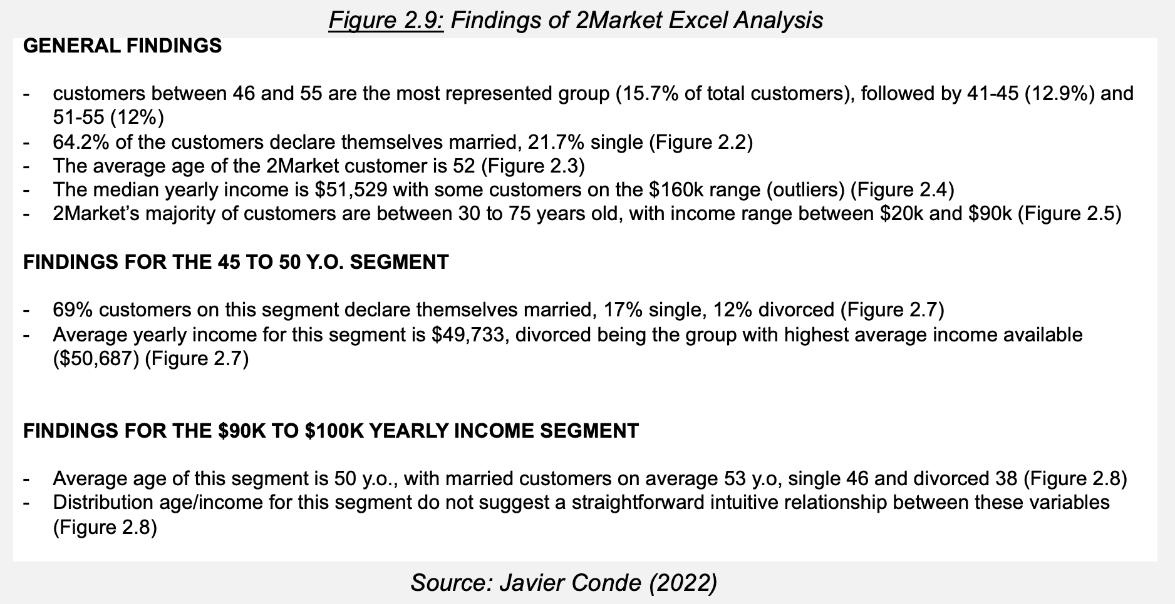

* 1. **SQL Analysis**

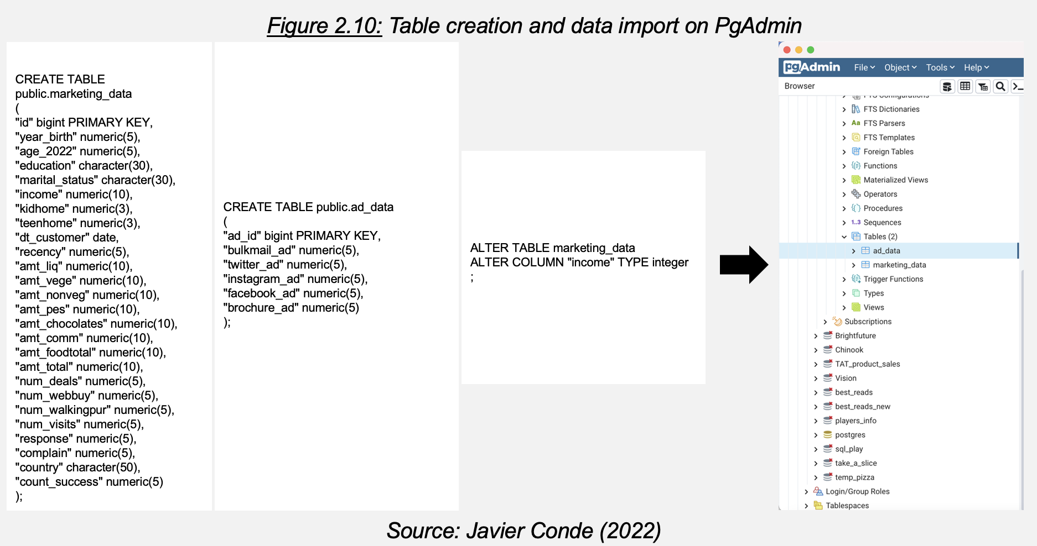

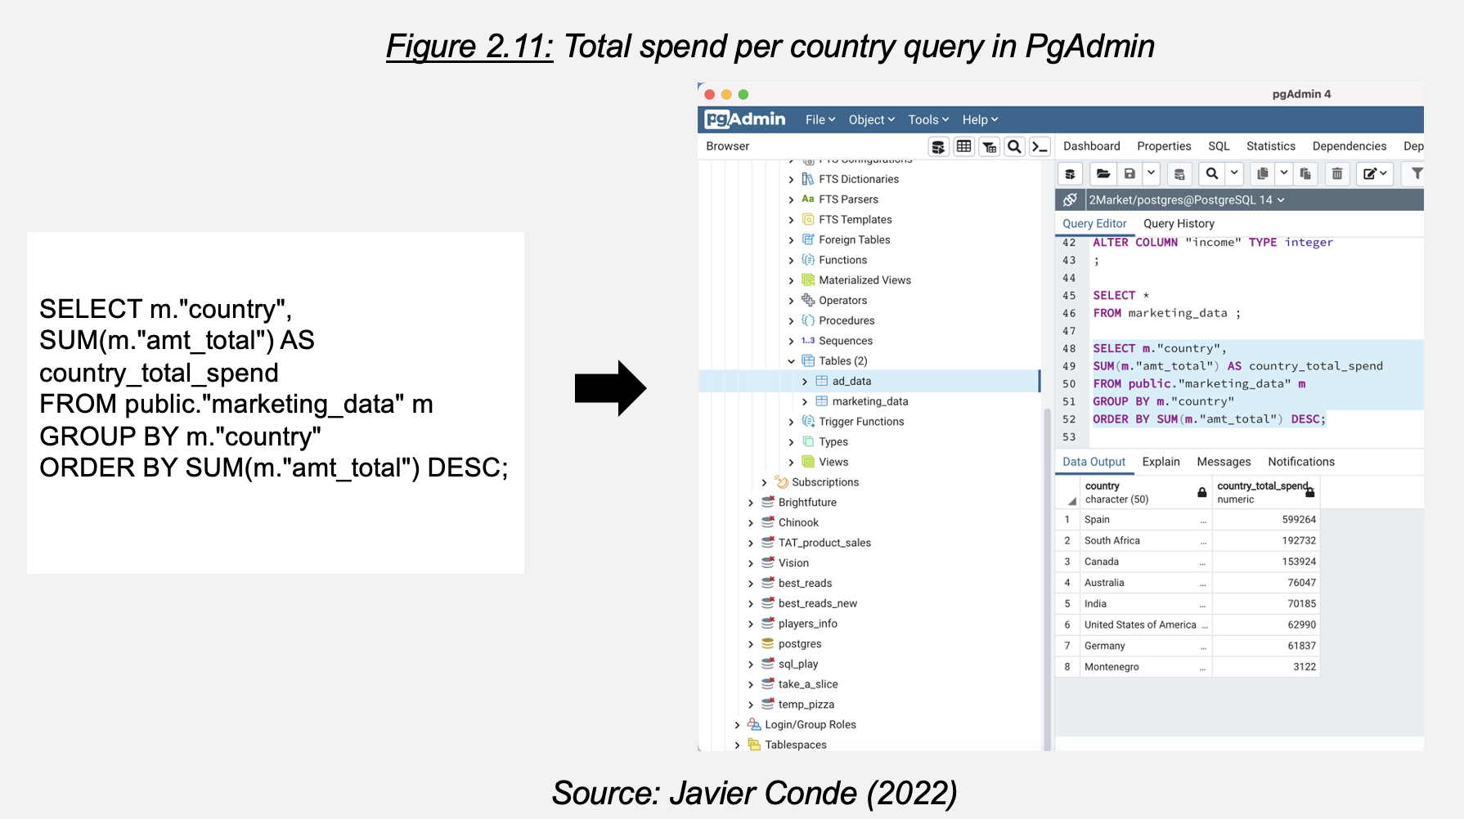

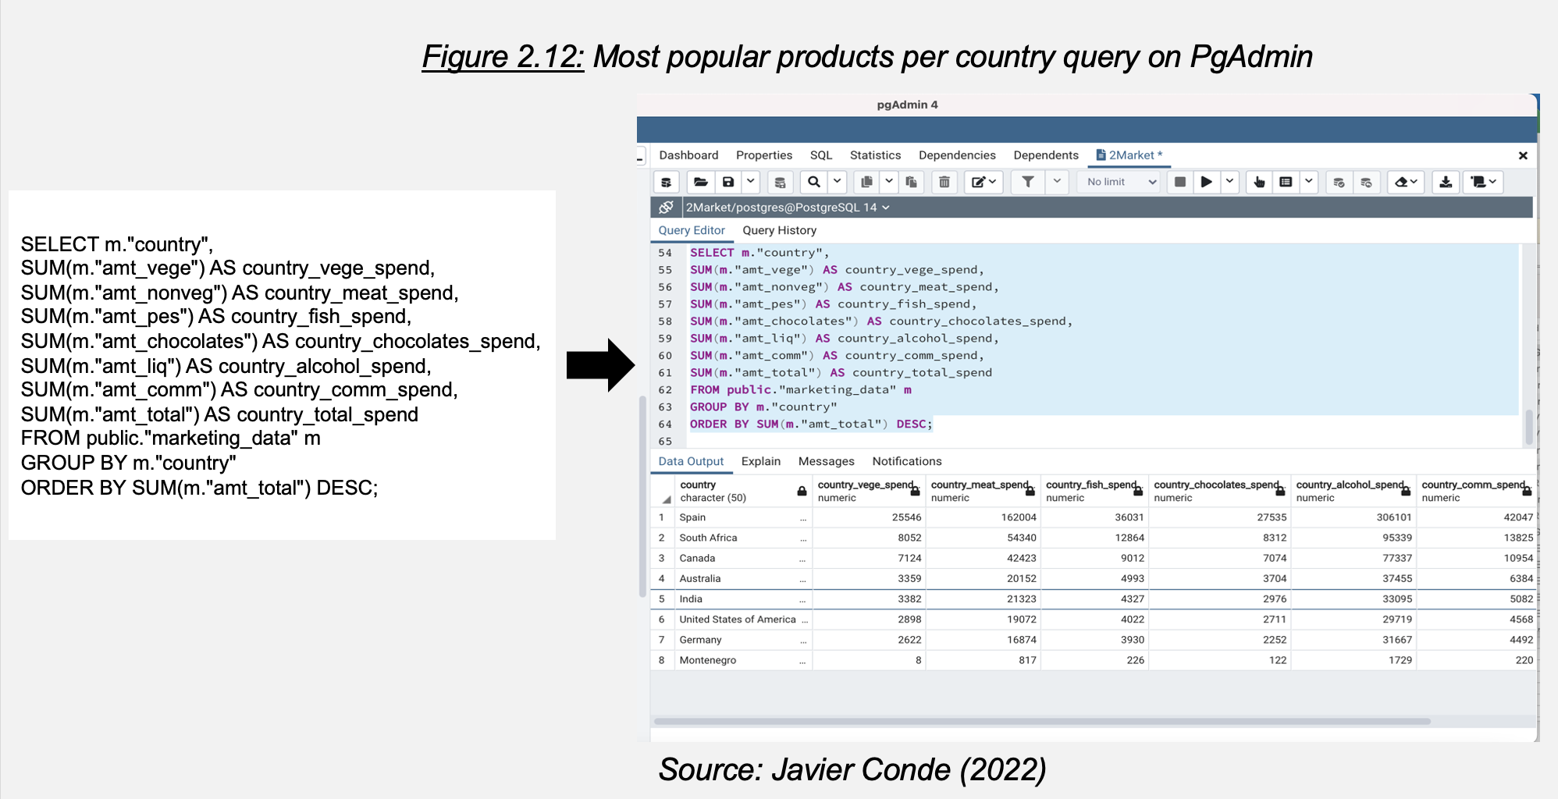

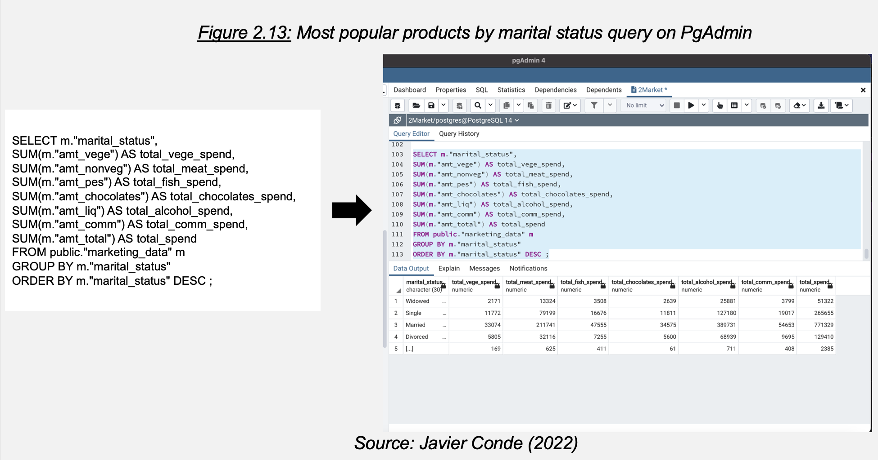

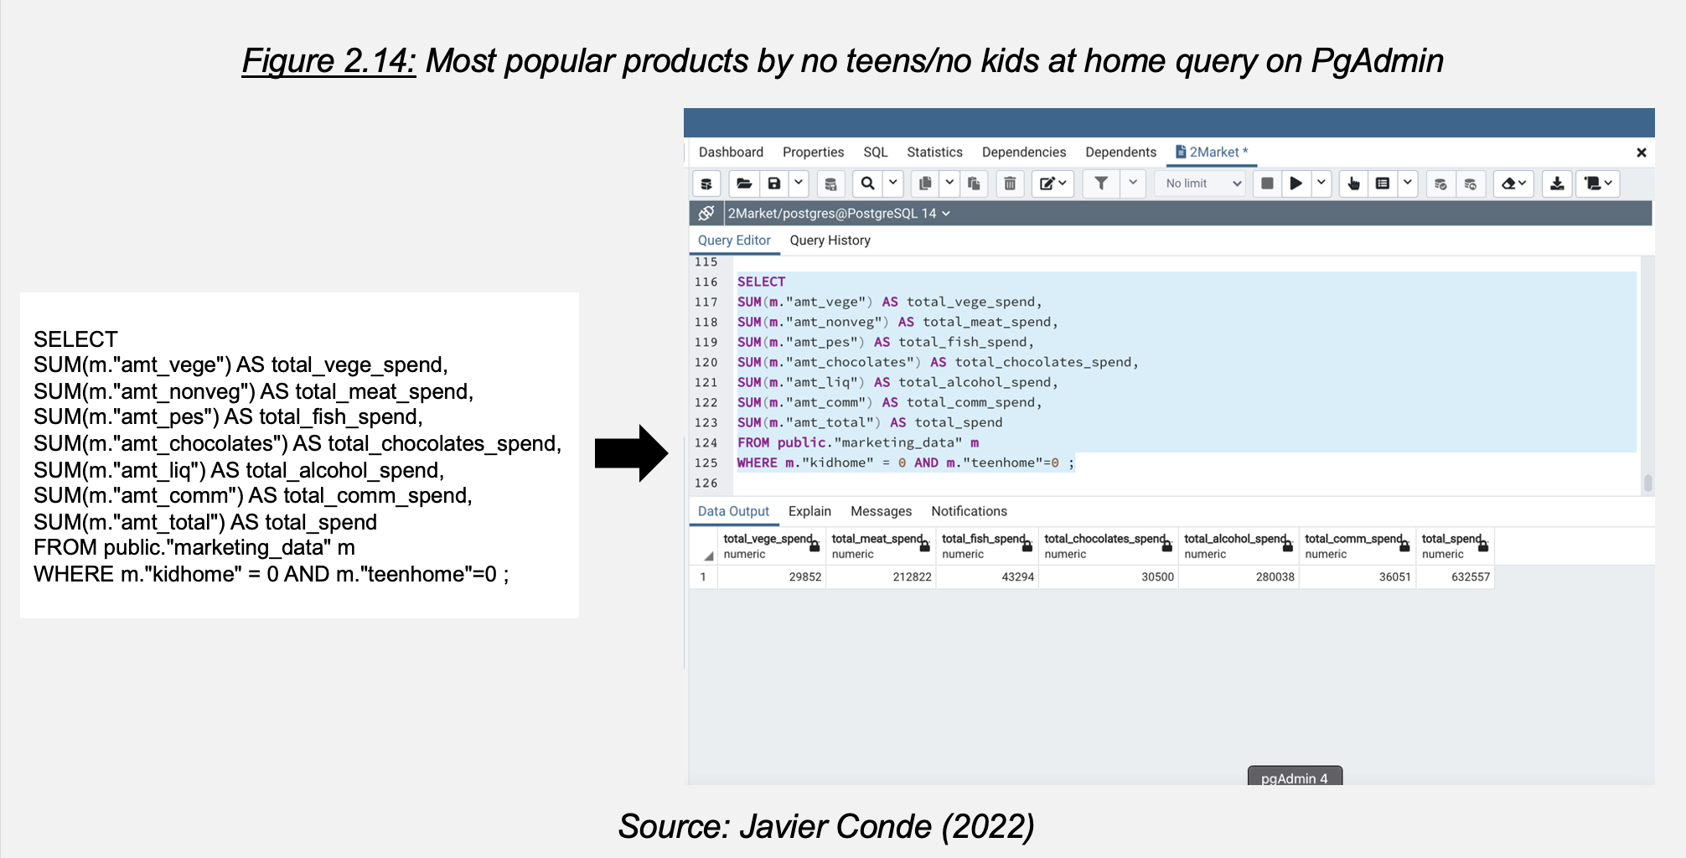

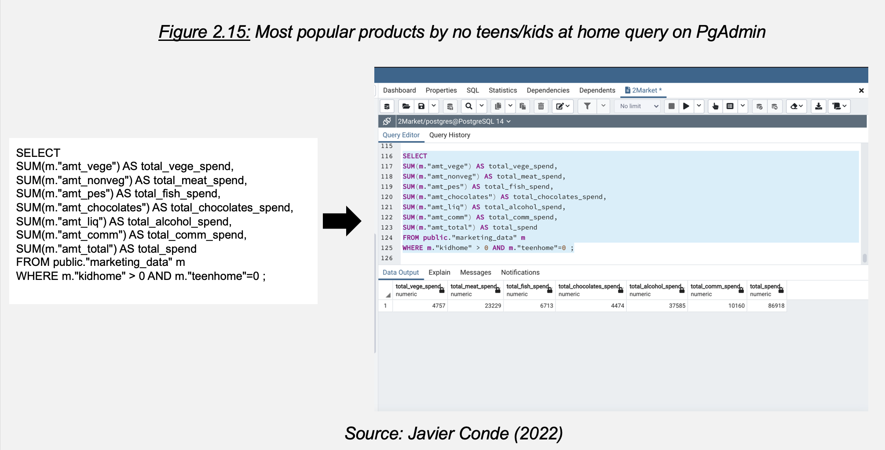

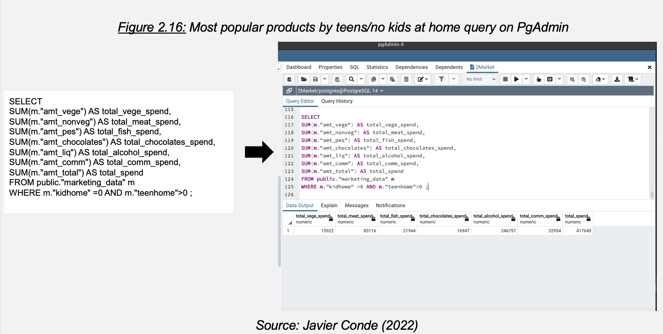

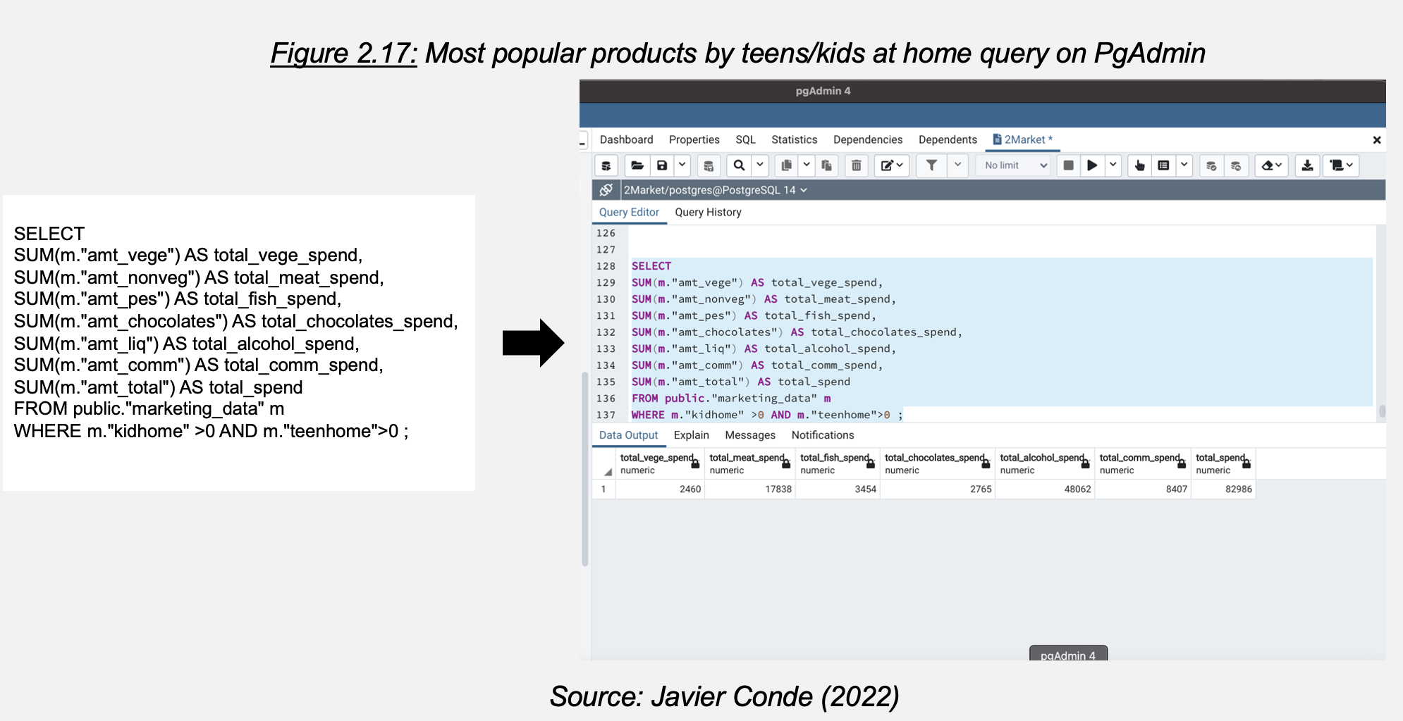

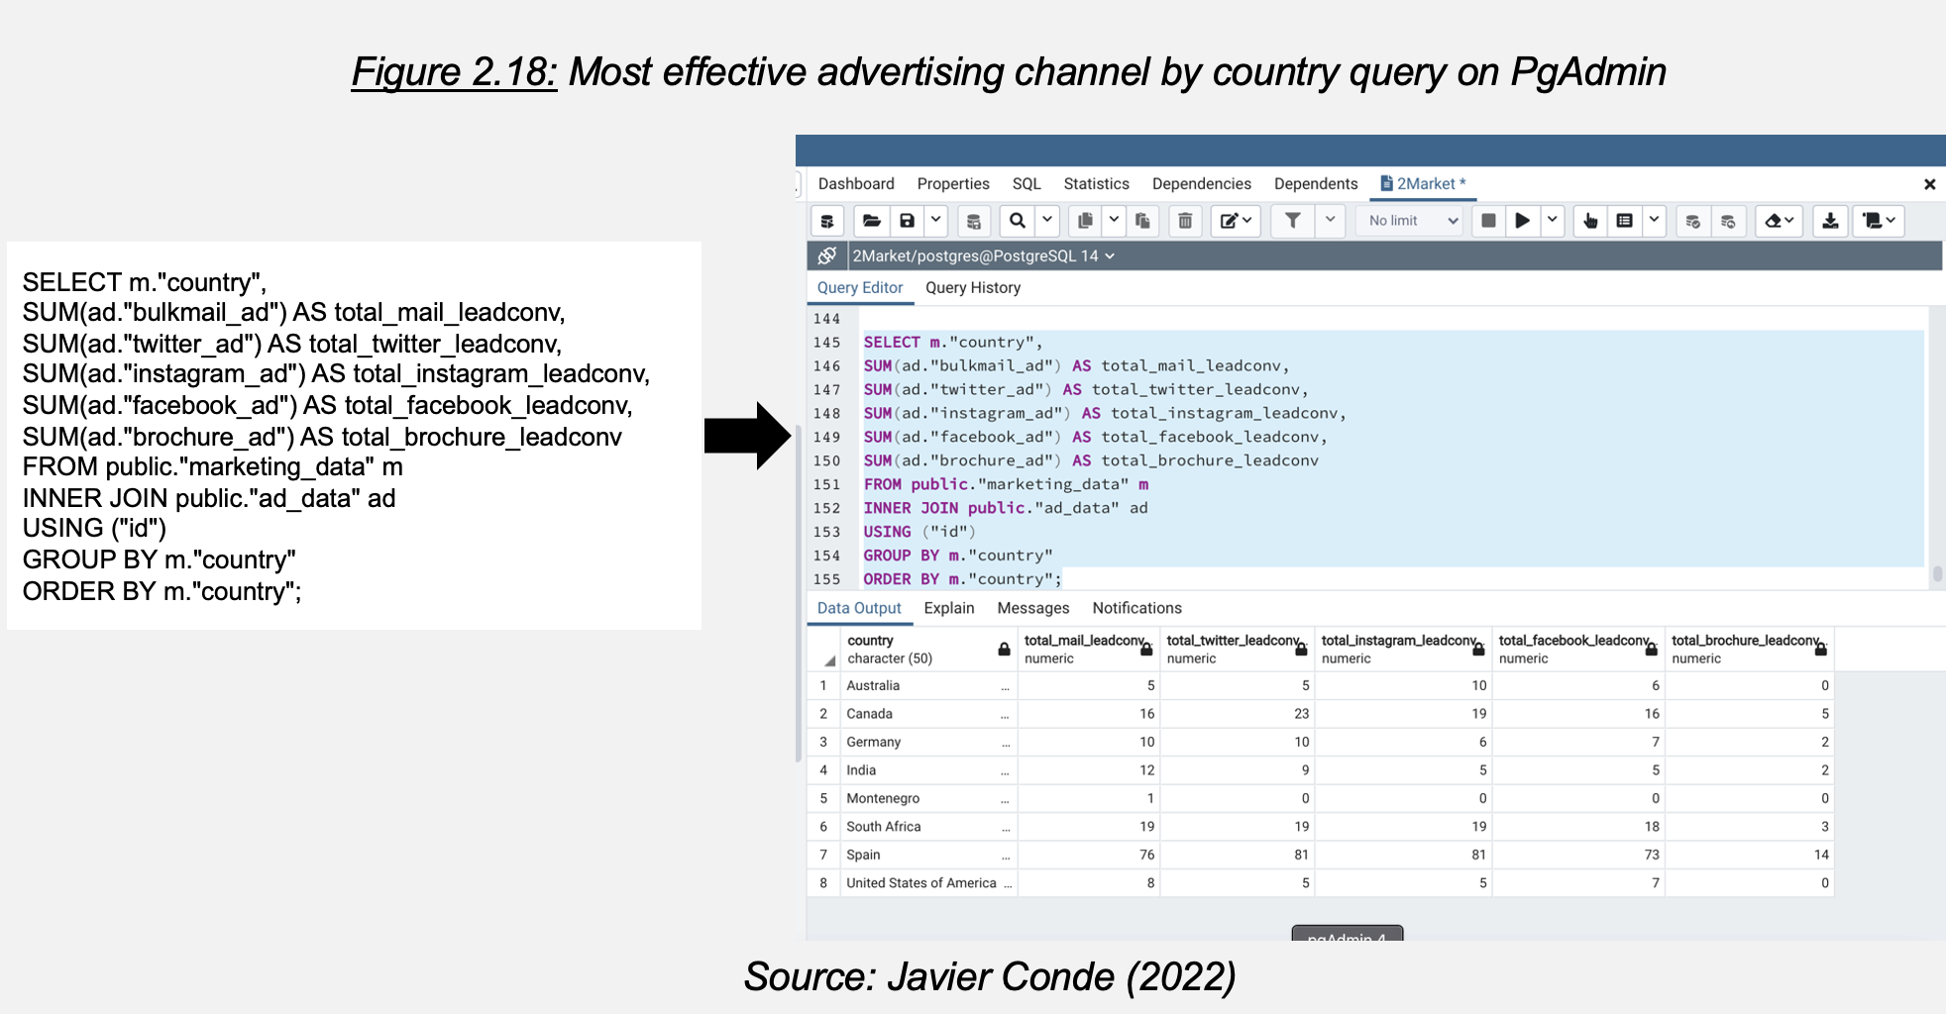

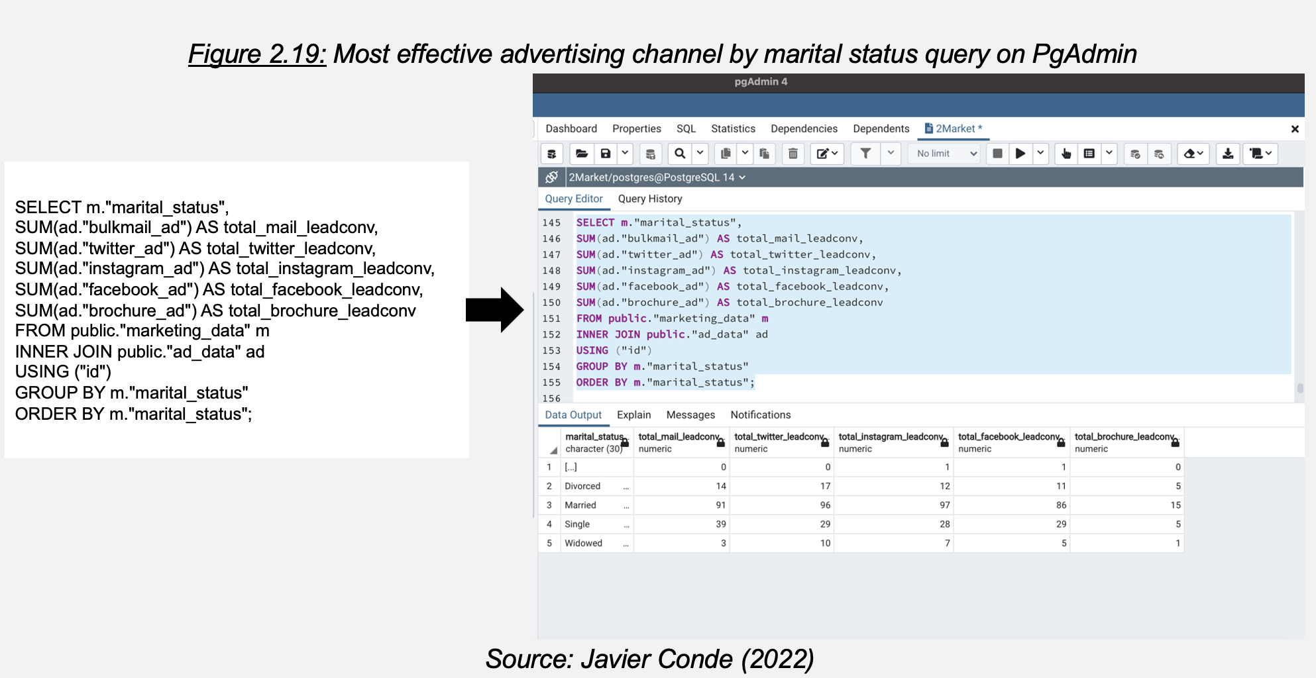

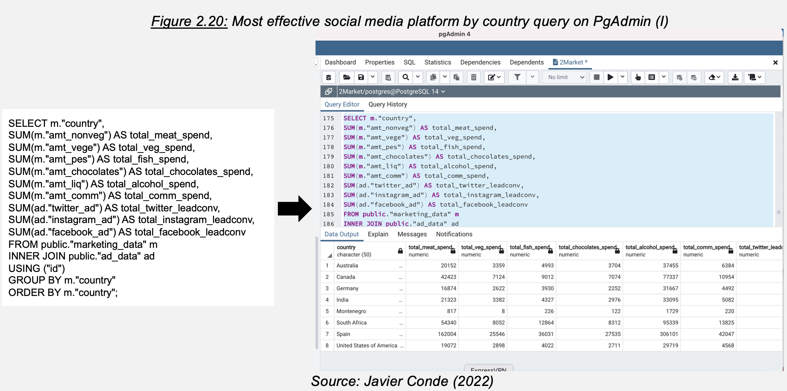

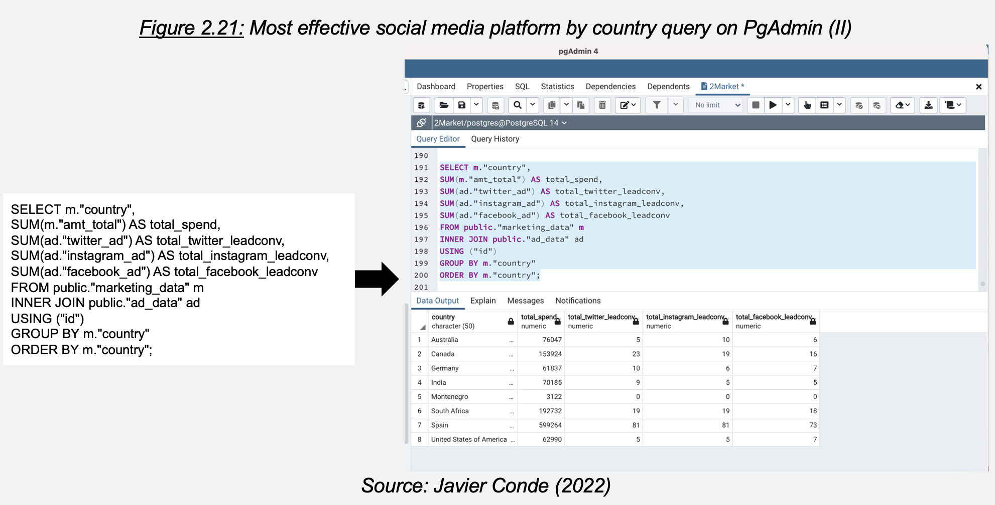

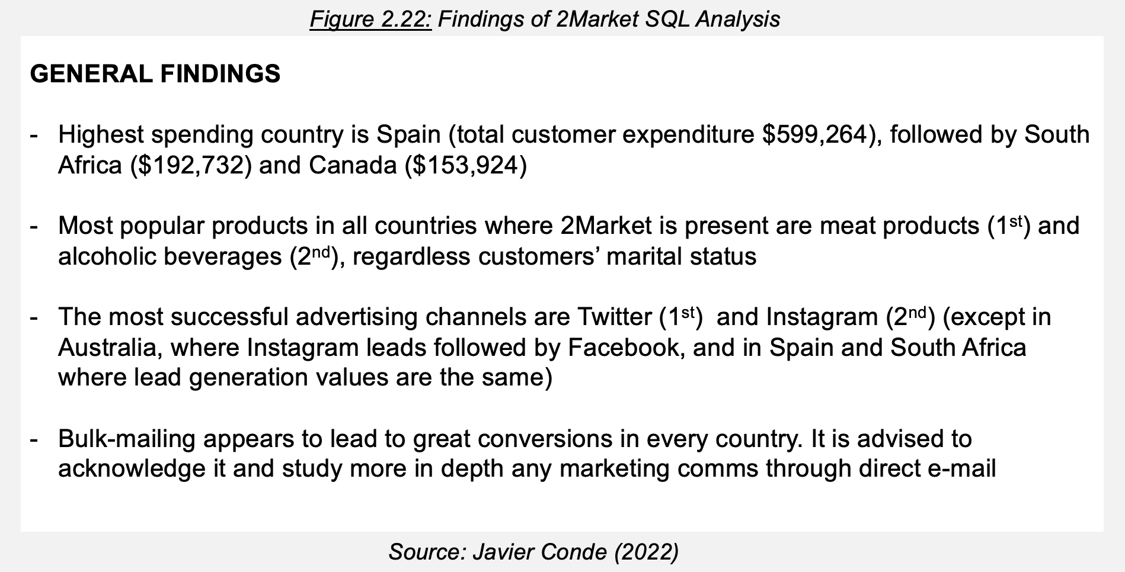

These XLSX and SQL findings evidence that 2Market would add enormous measurable value if they could have a flexible resource where they could have readily available demographic, geographic, and product sales insights through reliable metrics instantly. Let’s explore if a Tableau interactive dashboard could be that tool.

Chapter 3

**Dashboard design and development**

All cleaned data is already prepared to be imported into Tableau in XLSX format. Both files/tables (marketing_data CLEAN2.xlsx and ad_data CLEAN2, Figure 2.1) are imported and combined through an inner join, as what would deliver the bigger value in 2Market case is studying the data from values matching from both tables. In next stages the possibility of using an outer left join could be also explored (if the values from the marketing table that do not have a match on the ad table could reveal other insights).

The metrics that XLSX and SQL findings reveal as the more useful to 2Market to maximise value, make better informed business decisions and explore inside trends are as follows:

1. 2Market related: expenditure, product category, country, channel lead conversions
2. Customer related: marital status, age, yearly income

The dashboard built on these metrics will be designed to allow company stakeholders to explore their combination and maximise:

1. Data query flexibility (through graphics responsive to several filters at the same time)
2. User-friendliness
3. Accuracy, clarity, and stakeholder relevance (in this case, it is assumed that stakeholders may come from all levels -junior to executive- and departments across the organisation)
4. Interactivity (intuitive and easy to use filters and dynamic titles)
5. Accessibility (colour-blind and colour- contrast friendly colour palettes, font types and sizes, focus from left-top to right-bottom, use of intuitive bar charts and simple numerical displays)
6. Insightfulness (truly helps its users to explore new, useful, reliable data and make informed business decisions)
7. Business ethics (no sensitive data displayed in the dashboard)

With all these points in mind, a first draft on paper is designed to be translated to Tableau (Figure 3.1 below).

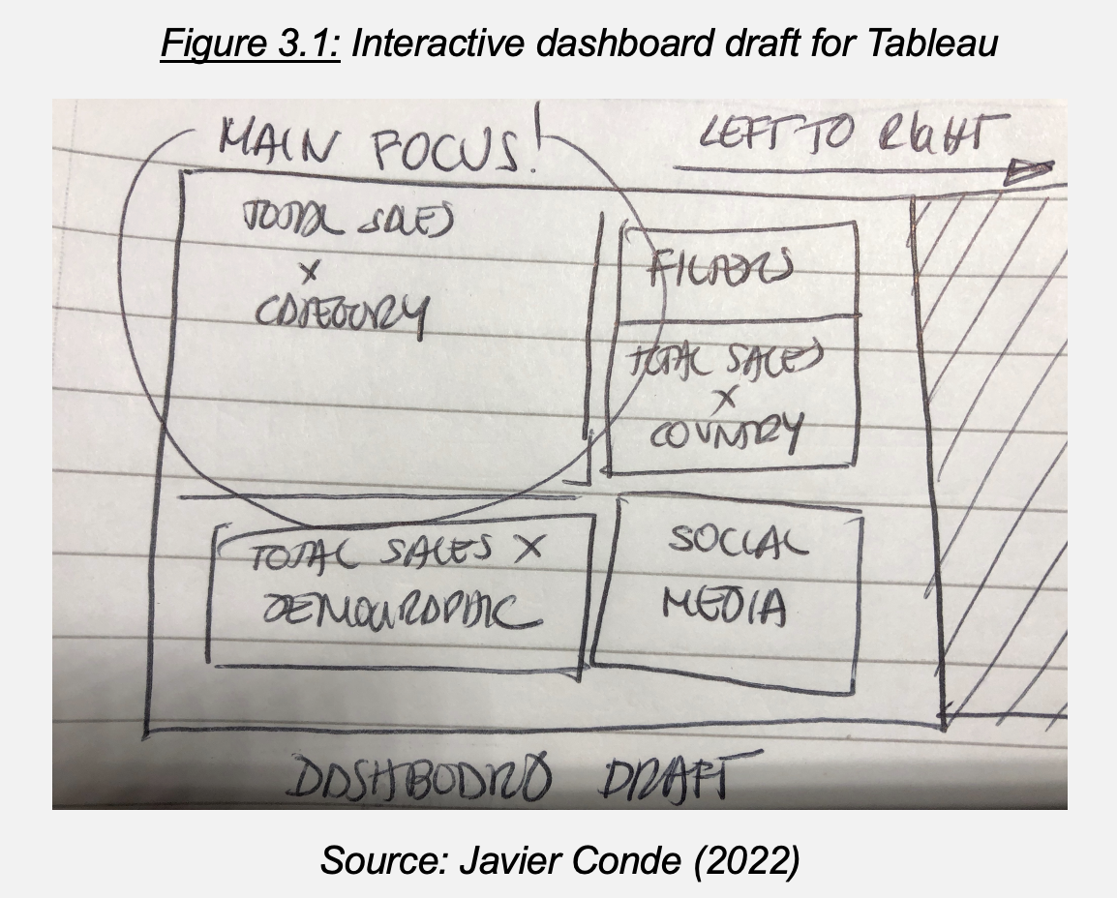

The metrics that will feed this dashboard are defined as:

1. Expenditure per month by product
2. Expenditure per age category (in bins of data width 5: e.g., value “25” meaning customers 25-30 y.o.)
3. Expenditure per marital status and country
4. Average yearly income per country
5. Ad lead conversion per age category

These concepts and metrics translate into the below Tableau Interactive Dashboard for 2Market as shown in Figure 3.2.

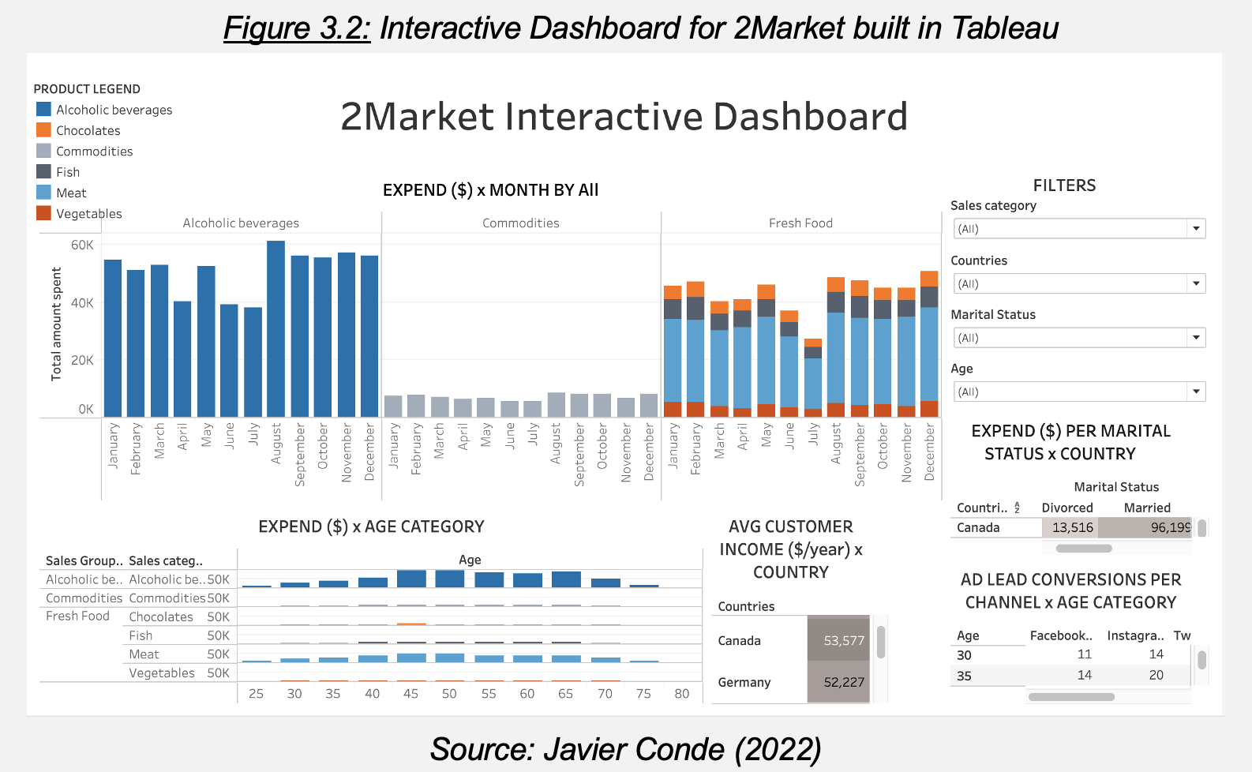

Let’s finalize this report exploring the insights and patterns that this dashboard uncovers, with further advice and recommendations for 2Market to consider exploring.

Chapter 4

**Patterns, trends, insights, recommendations**

At first glance immediate and visible insights emerge while exploring this dashboard:

1. Trend across all product categories and almost every country: customer expenditure decreases during summer months with an increase in September/October, slow decreasing again until end of the year (e.g., USA and Spain, Figure 4.1 below). This may suggest a seasonal expenditure pattern to be researched further, helpful to plan seasonal discounts/marketing actions to increase profits and margins

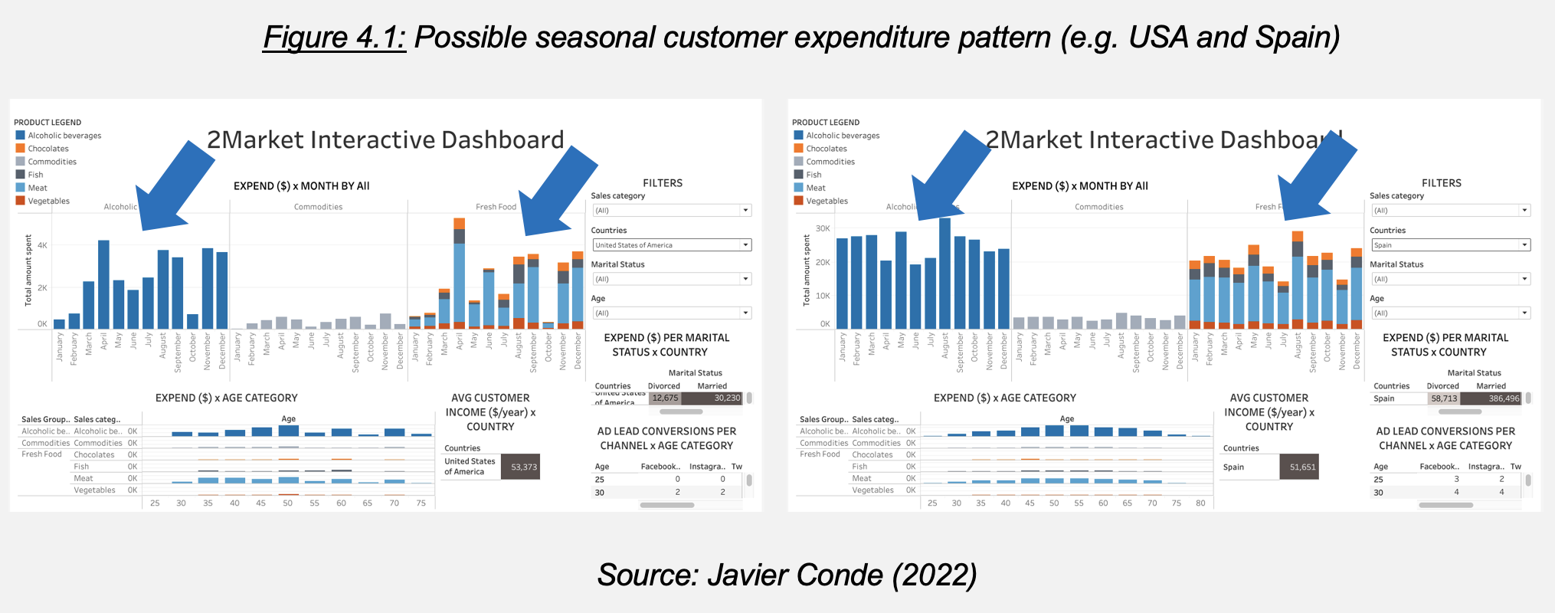

1. Confirming the finding during SQL analysis: alcoholic beverages and meat products emerge are best-selling products globally. Particularly popular among 45 to 60 y.o. customer segments (Figure 4.2 below). An opportunity is visible to consider tailored promotions through social media, maybe geographically/ locally targeted (on Twitter and Instagram, also identified previously as most successful advertising channels, supported by regular bulk mailing)

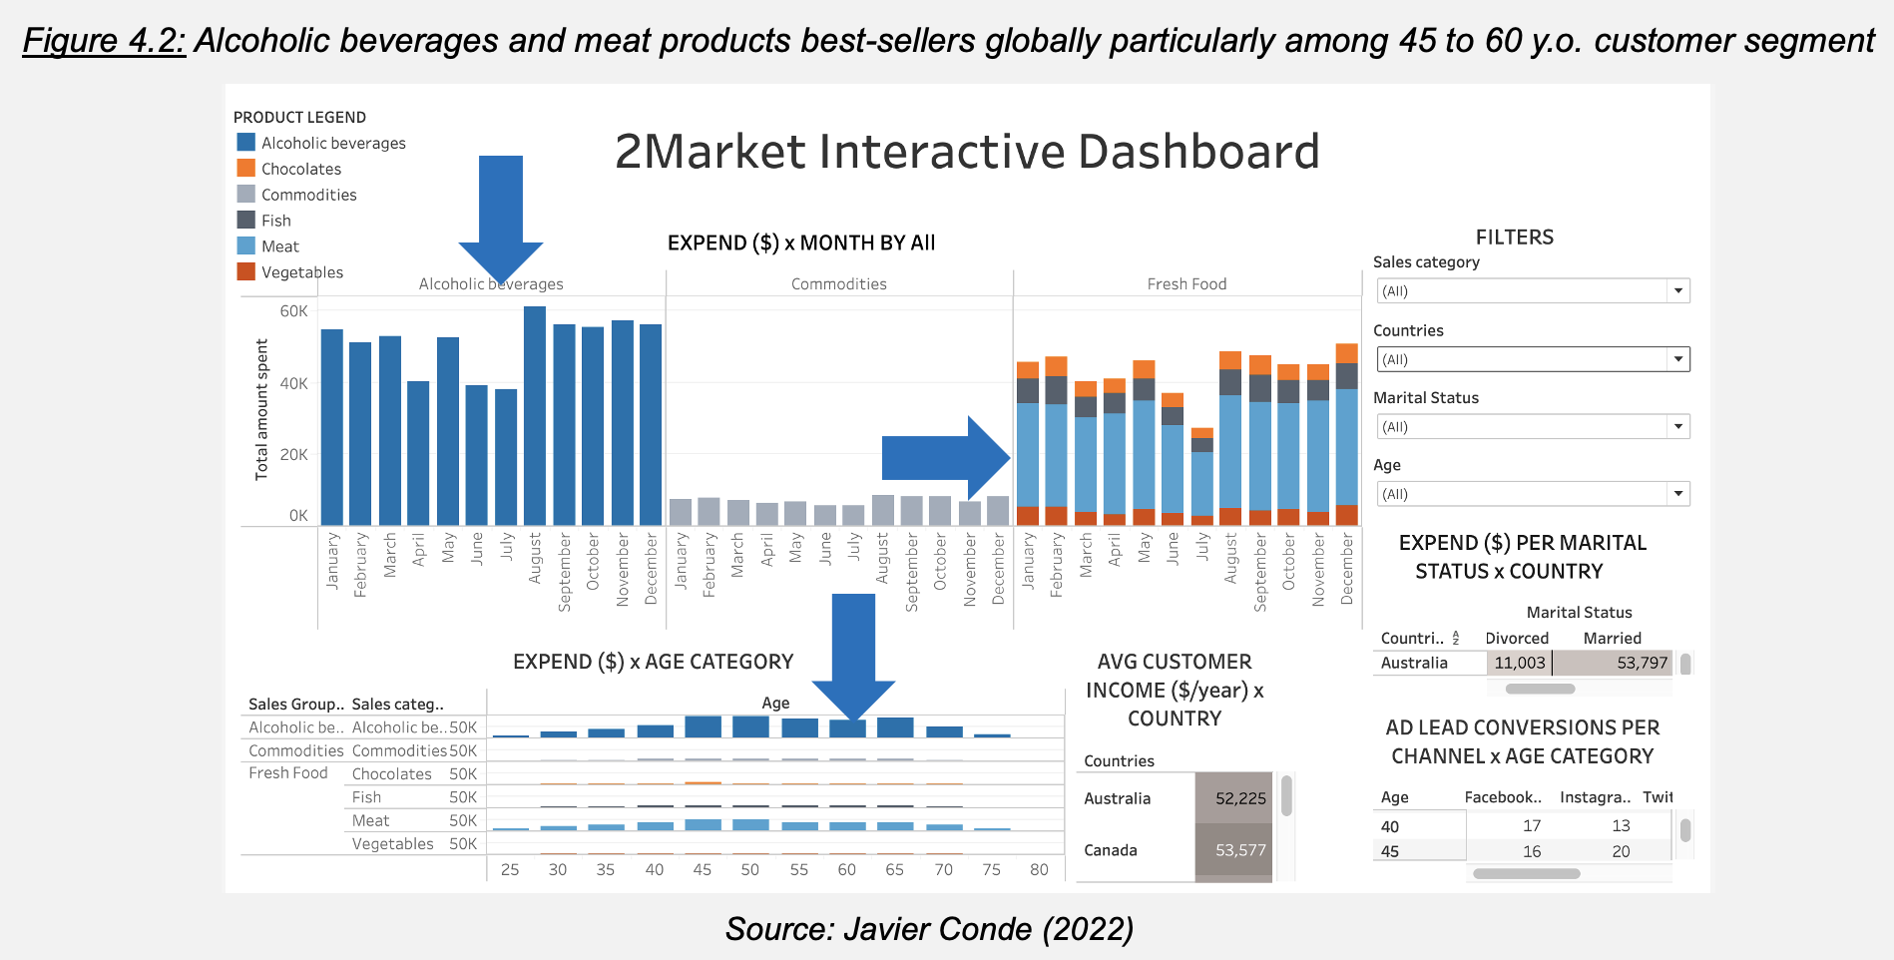

1. There also may be an unexplored opportunity to reach other customer profiles and attract a younger demographic. The dashboard unveils countries with higher customer income available for a range of age between 25 and 40 y.o. (e.g. Canada or Germany) with increasing expending power (Figure 4.3 below).

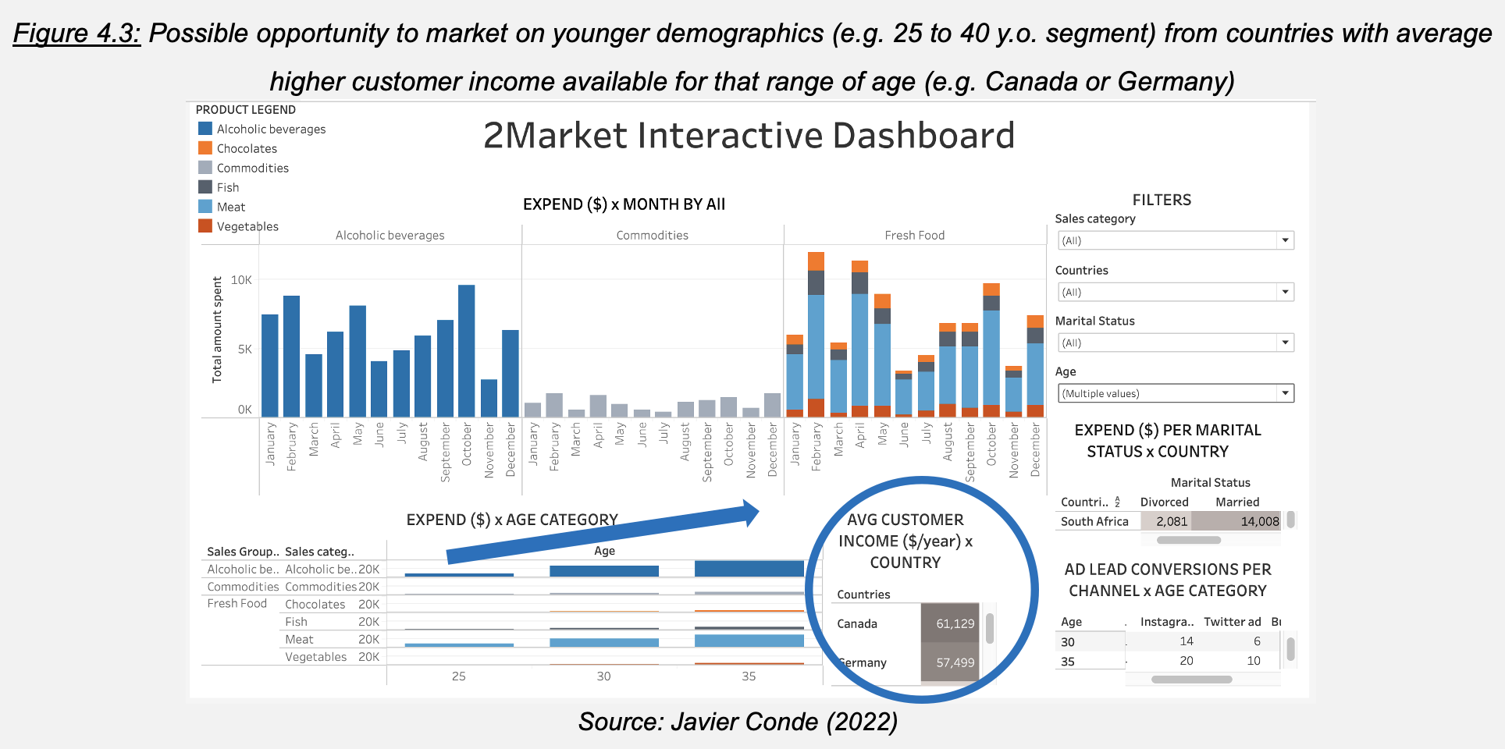

Two last recommendations for 2Market: taking initiatives to expand the data available to more recent years (increasing the forecasting potential of this dashboard) and being extremely vigilant (and increase when possible) about the quality of their data: reducing their current ratio of 9.2% duplicated records would boost noticeably the accuracy of this 2Market dashboard.

**Reference List**

* Gov.uk (2020) *Guidance: The Government Data Quality Framework.* Available at: <https://www.gov.uk/government/publications/the-government-data-quality-framework/the-government-data-quality-framework> (Accessed 18 April 2022)

**List of Figures**

* Figure 1.1: Background, project goal and questions to answer (LSE, 2022)
* Figure 1.2: Project Github repository (I) (Javier Conde, 2022)
* Figure 1.3: Project Github repository (II) (Javier Conde, 2022)
* Figure 2.3: Average age of 2Market customers (per marital status and total) (Javier Conde, 2022)
* Figure 2.4: Quartile/Median distribution for customers yearly income (Javier Conde, 2022)
* Figure 2.5: Distribution between customer yearly income and customer age (Javier Conde, 2022)
* Figure 2.6: Percentage per marital status and yearly income (per marital status and total) in 45 to 50 y.o. customer segment (Javier Conde, 2022)
* Figure 2.7: Average customer age per marital status in $90k to $100k yearly income customer segment (Javier Conde, 2022)
* Figure 2.8: Distribution of customers yearly income ($90k to $100k range) x customer age (Javier Conde, 2022)
* Figure 2.9: Findings of 2Market Excel Analysis Source (Javier Conde, 2022)
* Figure 2.10: Table creation and data import on PgAdmin (Javier Conde, 2022)
* Figure 2.11: Total spend per country query in PgAdmin (Javier Conde, 2022)
* Figure 2.12: Most popular products per country query on PgAdmin (Javier Conde, 2022)
* Figure 2.13: Most popular products by marital status query on PgAdmin (Javier Conde, 2022)
* Figure 2.14: Most popular products by no teens/no kids at home query on PgAdmin (Javier Conde, 2022)
* Figure 2.15: Most popular products by no teens/kids at home query on PgAdmin (Javier Conde, 2022)
* Figure 2.16: Most popular products by teens/no kids at home query on PgAdmin (Javier Conde, 2022)
* Figure 2.17: Most popular products by teens/kids at home query on PgAdmin (Javier Conde, 2022)
* Figure 2.18: Most effective advertising channel by country query on PgAdmin (Javier Conde, 2022)
* Figure 2.19: Most effective advertising channel by marital status query on PgAdmin (Javier Conde, 2022)
* Figure 2.20: Most effective social media platform by country query on PgAdmin (I) (Javier Conde, 2022)
* Figure 2.21: Most effective social media platform by country query on PgAdmin (II) (Javier Conde, 2022)
* Figure 2.22: Findings of 2Market SQL Analysis (Javier Conde, 2022)
* Figure 3.1: Interactive dashboard draft for Tableau (Javier Conde, 2022)
* Figure 3.2: Interactive Dashboard for 2Market built in Tableau (Javier Conde, 2022)
* Figure 4.1: Possible seasonal customer expenditure pattern (e.g. USA and Spain) (Javier Conde, 2022)
* Figure 4.2: Alcoholic beverages and meat products best-sellers globally particularly among 45 to 60 y.o. customer segment (Javier Conde, 2022)
* Figure 4.3: Possible opportunity to market on younger demographics (e.g. 25 to 40 y.o. segment) from countries with average higher customer income available for that range of age (e.g. Canada or Germany) (Javier Conde, 2022)